More strangeness

* Callee does not give a name to the (potential) block argument
* Instead, just calls it will yield or yield (args)
  + Silly example:

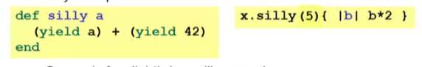

* + - See code for slightly less silly example
* Can ask block_given? But often just assume a block is given or that a block’s presence is implied by other arguments

Example

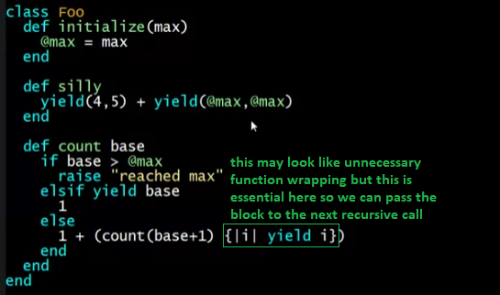

Load and initialize max

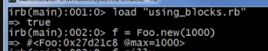

Silly method with no block passed

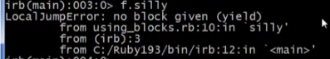

* Because of yield here:

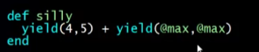

Silly method with 1 block passed



* 
* yield(4,5) --> 2*4 – 5 --> 3
* yield(1000, 1000) --> 2*1000 – 1000 --> 1000
* 3 + 1000 = **1003**

Count method



*  -> (10 * 10) == (34 * 10)